# Assignment and Tasks

1. Kindly follow below doc and link to get more details about the Isolation Levels.
   1. Isolation Level : <https://www.c-sharpcorner.com/blogs/using-isolation-level-in-sql-transaction2>
2. Advantage and Disadvantage of Dynamic SQL Queries.
3. Create a dynamic query and execute it via stored procedure. Take reference of example from recordings.

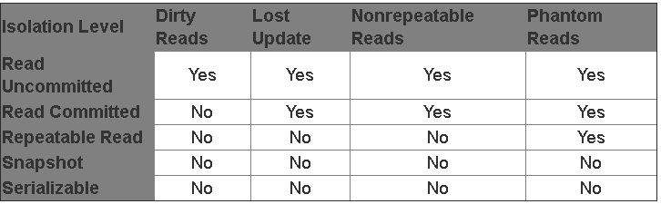

Isolation levels are required to remove below issues:

**Some of the common concurrency problems**

* Dirty Reads
* Lost Updates
* Nonrepeatable Reads
* Phantom Reads

Dirty Read

A dirty read happens when one transaction is permitted to read data that has been modified by another transaction that has not yet been committed. In most cases this would not cause a problem. However, if the first transaction is rolled back after the second reads the data, the second transaction has dirty data that does not exist anymore.

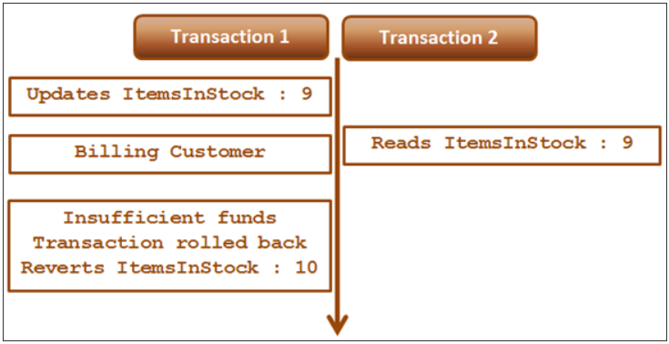

Lost UPDATE ISSUE

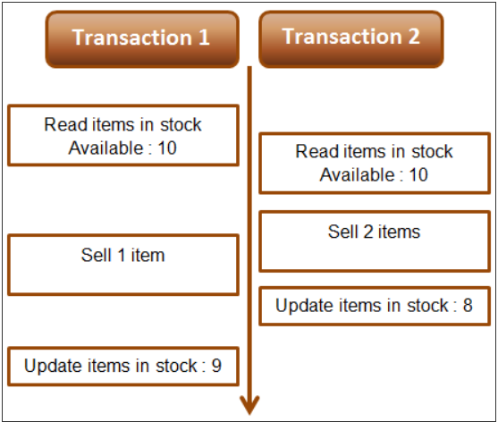

Non-Repeatable Read

Non repeatable read problem happens when one transaction reads the same data twice and another transaction updates that data in between the first and second read of transaction one.

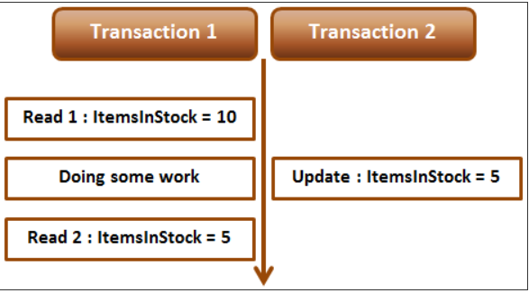

**Fixing non repeatable read concurrency problem :** To fix the non-repeatable read problem, set transaction isolation level of Transaction 1 to repeatable read. This will ensure that the data that Transaction 1 has read, will be prevented from being updated or deleted elsewhere. This solves the non-repeatable read problem.

-**Phantom Read**

**The following diagram explains the problem :** Transaction 1 starts first. Reads from Emp table where Id between 1 and 3. 2 rows retrieved for first read. Transaction 1 is doing some work and at this point Transaction 2 starts and inserts a new employee with Id = 2. Transaction 1 then makes a second read. 3 rows retrieved for second read, reulting in phantom read problem.

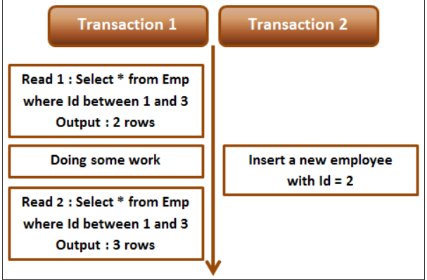

**Difference between repeatable read and serializable**  
**Repeatable read prevents only non-repeatable read.** Repeatable read isolation level ensures that the data that one transaction has read, will be prevented from being updated or deleted by any other transaction, but it doe not prevent new rows from being inserted by other transactions resulting in phantom read concurrency problem.   
  
**Serializable prevents both non-repeatable read and phantom read problems.**Serializable isolation level ensures that the data that one transaction has read, will be prevented from being updated or deleted by any other transaction. It also prevents new rows from being inserted by other transactions, so this isolation level prevents both non-repeatable read and phantom read problems.